भारतमौसमविज्ञानविभाग |  | India Meteorological Department
Wednesday,04th June 2025 (14 Jyeshtha 1947 Saka)
Summary of observations recorded at 0830 hoursIST: The Northern Limit of Monsoon continues to pass through 17.0°N/55°E, 17.5°N/60°E, 18°N/65°E, 18.5°N/70°E, Mumbai, Ahilyanagar, Adilabad, Bhawanipatna, Puri, Sandhead Island, 23.5°N/89.5°E, Balurghat, 30°N/85°E. The Western Disturbance as a cyclonic circulation over Punjab & neighbourhood lay as trough in middle & upper tropospheric levels with its axis at 5.8 km above m. s. l. roughly along Long. 76°E to the north of Lat. 28°N. An upper air cyclonic circulation lay over south Punjab & neighbourhood at 1.5 km above m. s. l. An upper air cyclonic circulation lay over north Bangladesh & neighbourhood at 0.9 km above m. s. l. An upper air cyclonic circulation lay over northeast Assam & neighbourhood at 0.9 km above m. s. l. An upper air cyclonic circulation lay over south Gujarat & neighbourhood between 1.5 & 3.1 km above m. s. l. A north-south trough ran roughly along Long. 87°E to the north of Lat. 22°N at 3.1 km above m. s. l. The upper air cyclonic circulation over northwest Uttar Pradesh became less marked. The north-south trough roughly along Long. 92°E to the north of Lat. 22°N became less marked. The upper air cyclonic circulation over east Bihar became less marked. The upper air cyclonic circulation over Haryana became less marked.
Day temperatures were markedly above normal (> 5.1°C) at isolated places over Tamil Nadu, Puducherry & Karaikal; appreciably above normal (3.1°C to 5.0°C) at isolated places over Assam & Meghalaya, Gangetic West Bengal and Odisha; above normal (1.6°C to 3.0°C) at few places over Lakshadweep; at isolated places over Sub Himalayan West Bengal & Sikkim, East Uttar Pradesh, West Uttar Pradesh, Saurashtra & Kutch and Coastal Andhra Pradesh & Yanam and near normal (-1.5°C to 1.5°C) at many places over Kerala & Mahe; at most places over Andaman & Nicobar Islands, Arunachal Pradesh, Konkan & Goa and Coastal Karnataka; at few places over Bihar, West Rajasthan, East Madhya Pradesh and Gujarat Region; at isolated places over Himachal Pradesh, Rayalaseema and North Interior Karnataka. Yesterday, the highest maximum temperature of 42.6°C was reported at Banda (East Uttar Pradesh).
Hailstorm observed at isolated places over Jammu and Uttarakhand.
Preliminary Earthquake Report: An earthquake shock of Slight intensity at its origin with epicenter at Lat. 33.73° North and Long. 81.99° East, 304 km NE of Hanley, Jammu & Kashmir; India, China; about 1874 kms away from Pune, was recorded by the seismographs in the CR & S Office, Pune at 04 Hrs. 45 Min. 55 Secs. IST on 28-05-2025 having its magnitude 4.2 on the Richter scale.

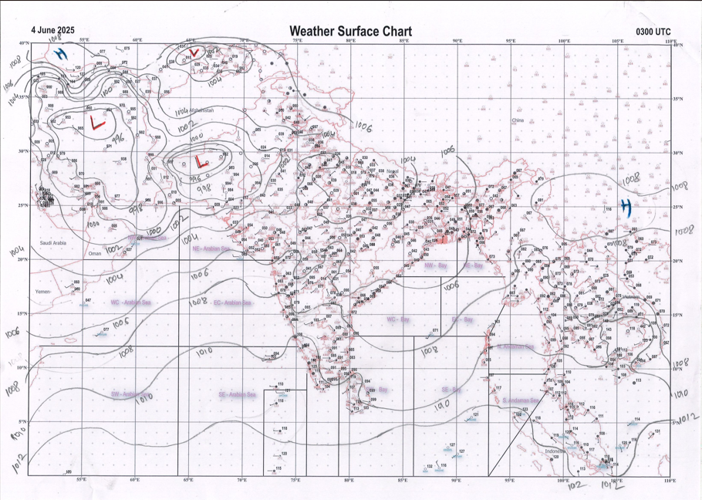 | 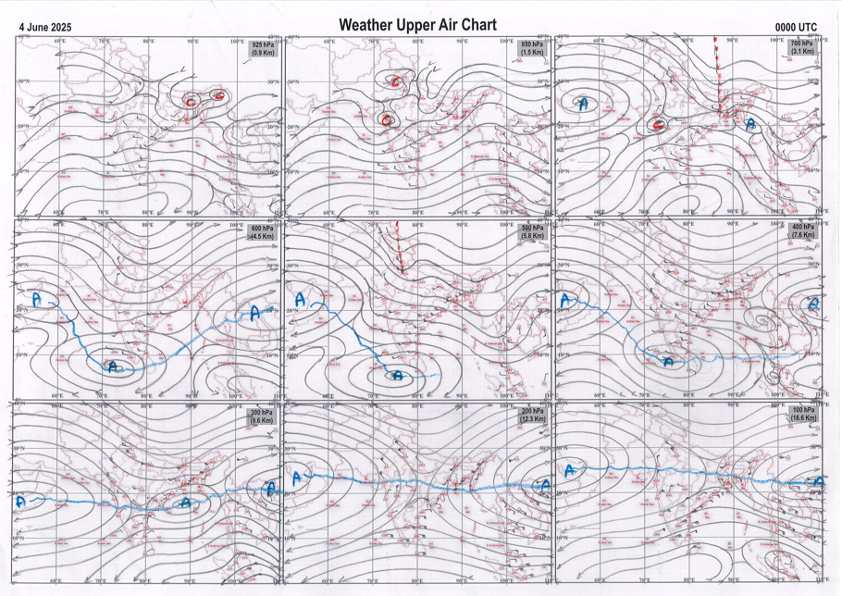
g.1. Analysed surface chart based on 03z observation | Fig.2. Analysed upper air chart based on 00z observation

Dr. S.D.Sanap
Scientist ‘D’
CR & S Office, Pune  Issued at 1245 hrs. IST |  | Weather Forecasting Division  CR&S, Pune

Indian regions | Realised rainfall (chief amount in cm during past 24 hrs):
East | most places: Sub-Himalayan West Bengal & Sikkim+++  many places: Arunachal Pradesh+, Nagaland-Manipur-Mizoram-Tripura and Gangetic West Bengal+  a few places: Assam & Meghalaya+ and Jharkhand  isolated places: Odisha  dry weather: Bihar  Gairkata tea estate 18.2, Cooch behar 13.9, Amfu pundibari 12.1, Dhubri CWC & Bahalpur 8.7 each, Mo saltlake 8.1, Naharlagun AWS 6.9, N.lakhimpur / Lilabari & Bankura (CWC) 6.7 each, Jiribam AWS, Dum dum & Bhubaneswar AP 5.7 each, Oyan ARG 4.1, Messenjor 3.6, Bagafa 3.2, Balipatna & Maithon dvc 2.4 each, Bamra 2.0, Imphal AP 1.7, Ranchi AP 1.6, Pasighat AP 1.0.
North | many places: Uttarakhand and Himachal Pradesh  isolated places: Uttar Pradesh, Haryana◆, Jammu-Kashmir and Ladakh and Rajasthan+  dry weather: Punjab  Parbatsar 7.7, Pachpahar SR 6.5, Karsog 6.4, Nainital 5.6, Anta SR 4.7, Kufri AWS 4.5, Chaukhutia 4.4, Simla 4.0, Bilaspur 3.7, Makrana SR 3.2, Bareilly CWC 3.0, Dehra dun 2.6, Bundi 2.2, Ganganagar 2.0, Banda CWC & Larnoo ARG 1.6 each, Kheri lakhimpur & Kukernag 1.2 each, Meja 1.0, Bareilly PBO & Qazi gund 0.8 each, Sports complex AWS 0.2, Jafarpur AWS 0.1.
Central | a few places: west Madhya Pradesh+  isolated places: east Madhya Pradesh, Vidarbha and Chhattisgarh  Bhanpura 8.4, Badi 4.6, Buxwaha 3.6, Raisen-aws 2.6, Raipura 2.3, Sagar-aws 1.1, Malkapur 0.9, Gadchiroli 0.6, Sakola 0.5, Chandrapur 0.3.
Peninsula | most places: Konkan & Goa+, coastal Karnataka and Kerala  a few places: south interior Karnataka  isolated places: Gujarat Region+, Saurashtra & Kutch, Madhya Maharashtra, coastal Andhra Pradesh, Telangana, Rayalaseema, Tamil Nadu and north interior Karnataka  dry weather: Marathwada  Thane 7.2, Idar 6.8, Kayamkulam 6.3, Ambernath 5.7, Matheran 5.5, Uppinangadi 4.9, Sojitra 4.8, Ayyankunnu AWS 4.7, Khambhat 4.0, Gokarna 3.4, Omalur 3.1, Wadhvan, Vanur & Bhagamandala 3.0 each, Kochi IAF 2.6, Palawancha 2.5, Gaganbawada 2.3, Chennai (n) & Kottigehara 2.1 each, Kurupam 1.8, Velhe, Mulakalapalle, Agali & Agumbe emo 1.5 each, Lakhtar & Surendranagar 1.3 each, Honavar 1.2, Jalgaon IMD pt 1.0, Madanapalle 0.9, Parvathipuram 0.8, Tavaragera & Adaki 0.7 each, Hanamkonda 0.5, Nandyal 0.3.
Islands | most places: Lakshadweep  a few places: Andaman & Nicobar  Hut bay 1.4, Port blair 1.0, Minicoy 0.8, Nancowry 0.7, Amini 0.4, Agathi 0.3.
Table 2. Forecast / warnings (distribution of rain / thundershowers) for 7 days (valid from time of origin upto 0830 hrs IST of next day)
Sr. No |  | Sub-division Name | Day 1 | Day 2 | Day 3 | Day 4 | Day 5 | Day 6 | Day 7 | Sr. No. | Sub-division Name | Day 1 | Day 2 | Day 3 | Day 4 | Day 5 | Day 6 | Day 7
 |  |  | 04 Jun | 05 Jun | 06 Jun | 07 Jun | 08 Jun | 09 Jun | 10 Jun |  |  | 04 Jun | 05 Jun | 06 Jun | 07 Jun | 08 Jun | 09 Jun | 10 Jun
 | 1 | Andaman Nicobar Islands | F | F | W | W | W | W | W | 19 | west Madhya Pradesh | S  | I  | I  | I  | I  | I | I
 | 2 | Arunachal Pradesh | W +  | F +  | F | F | F | F | F | 20 | east Madhya Pradesh | S  | I  | I  | I  | I  | I | I
 | 3 | Assam-Meghalaya | W #  | F +  | F  | S  | S  | F | F | 21 | Gujarat region | S +  | S | S | I | I | I | I
 | 4 | Nagaland-Manipur-Mizoram-Tripura | W +  | F +  | S  | S  | S  | F | F | 22 | Saurashtra and Kutch | S | I | I | I | I | I | I
 | 5 | Sub Himalayan West Bengal/Sikkim | W +  | F  | S | S | F | S | F | 23 | Konkan and Goa | W + | W  | S  | S | I | I | I
 | 6 | Gangetic West Bengal | F  | S  | I | I | I | I | I | 24 | Madhya Maharashtra | I  | S  | S  | S  | I | I | I
 | 7 | Odisha | I + | I + | I + | I | I | I | I | 25 | Marathwada | I | I | I  | I  | I  | I | I
 | 8 | Jharkhand | I  | I  | D | D | I | I | I | 26 | Vidarbha | I  | I  | I  | S  | S  | I | I
 | 9 | Bihar | S +  | S  | I | I | I | I | I | 27 | Chhattisgarh | I  | I  | I  | I  | I  | I | I
 | 10 | east Uttar Pradesh | I  | I | D | D | D | D | D | 28 | Coastal Andhra Pradesh and Yanam | I + | I  | I  | I  | I  | I | S
 | 11 | west Uttar Pradesh | I  | I | D | D | D | D | D | 29 | Telangana | I  | I  | I | I | I | I | I
 | 12 | Uttarakhand | F  | S  | I | D | D | D | D | 30 | Rayalaseema | I | I | I | I | I | S | S
 | 13 | Haryana,Chandigarh and Delhi | I  | I | D | D | D | D | D | 31 | Tamil Nadu, Puducherry and Karaikal | I  | I  | I | I | I | I | S
 | 14 | Punjab | I  | I | D | D | D | D | D | 32 | Coastal Karnataka | W  | F  | F  | W  | W  | W | F
 | 15 | Himachal Pradesh | F  | S  | I | D | D | D | D | 33 | North interior Karnataka | I  | I  | S  | S  | F  | S | S
 | 16 | Jammu-Kashmir and Ladakh | S  | I | D | D | D | D | D | 34 | South interior Karnataka | I  | I  | S  | S  | F | S | S
 | 17 | west Rajasthan | I  | I  | D | D + | D + | D + | D | 35 | Kerala and Mahe | W + | F | S | S | S | S | F
 | 18 | east Rajasthan | S  | I  | I  | I  | I | D | D | 36 | Lakshadweep | W  | F | S | S | S | F | F
Legends: D = DryI = IsolatedS = ScatteredF = Fairly widespreadW = Widespread #= heavy to very heavy rain at a few places with extremely heavy rain at isolated places +++= heavy rain at a few places with very heavy rain at Isolated places ++= heavy to very heavy rainfall @=Isolated exceptionally heavy rainfall + = heavy rain ●/*= rain or snow ♦ = very light rain ≡=fog= thunderstorm with lightning =Squall / Gusty / gale / strong wind ­ =cold wave/cold day += heat wave/warm night/hot and humid weathe r=Duststorm =ground frost = Hail

Fig. 4: Districtwise warnings for five days for Maharashtra State
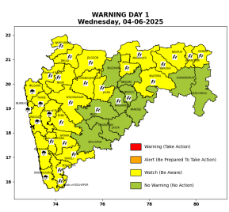 | 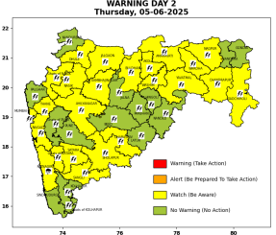 | 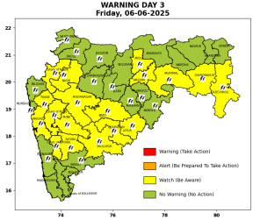 | 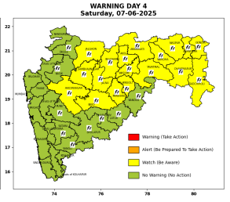 | 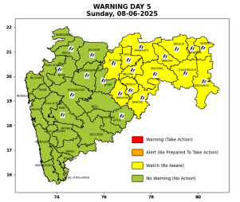

Pune, Lohegaon and Pashan observations at 0830 hrs. IST of Today
 | Temperature (°C) |  |  |  |  | Humidity (%) |  |  |  | Rainfall (mm)
 | Max.  past  24 hrs | Dep.  from  normal | Min.  past  24 hrs. | Dep.  from  normal | Dry  Bulb | At 0830 hrs. IST | Dep.  From  normal | At 1730  hrs. IST of y’day | Dep.  from  normal | Past  24 hrs. | Since  1st June | Dep.  from  normal
PNE | 32.2 | -3.5 | 22.6 | -1.0 | 27.4 | 72 | 3 | 57 | 6 | 0.0 | 1.2 | -13.8
PSN | 31.5 | - | 21.8 | - | 26.4 | 79 | - | 63 | - | 0.0 | 0.2 | -
LHG | 33.9 | -0.1 | 24.6 | 3.6 | 29.6 | 56 | -13 | 45 | -6 | 0.0 | 4.0 | -10.4

 |  |  |  |  |  |  | Local (Pune and neighbourhood) forecast
Max./Min. Temperature (°C) |  |  |  |  |  |  |  |  | Weather
Date | Pune | Pashan | Lohegaon | Chinchwad | Lavale | Magarpatta | NDA | Koregoan Park
04/06/25 | 26/22.6* | 26/21.8* | 28/24.6* | 27/24.6* | 25/22.7* | 29/25.2* | 27/22.7* | 29/24.5* | Partly cloudy sky becoming generally cloudy sky towards afternoon/evening. Thunderstorm with lightning, light to moderate rain very likely.
05/06/25 | 27/23 | 27/22 | 29/25 | 28/25 | 26/23 | 28/25 | 26/23 | 29/25 | Partly cloudy sky becoming generally cloudy sky towards afternoon/evening. Thunderstorm with lightning, light to moderate rain very likely.
06/06/25 | 27/22 | 27/21 | 29/24 | 28/24 | 26/22 | 28/24 | 26/22 | 29/24 | Partly cloudy sky becoming generally cloudy sky towards afternoon/evening. Thunderstorm with lightning, light to moderate rain very likely.
07/06/25 | 26/22 | 26/21 | 28/24 | 27/24 | 25/22 | 27/24 | 25/22 | 28/24 | Partly cloudy sky becoming generally cloudy sky towards afternoon/evening. light rain likely.
08/06/25 | 27/21 | 27/20 | 29/23 | 28/23 | 26/21 | 28/23 | 26/21 | 29/23 | Partly cloudy sky becoming generally cloudy sky towards afternoon/evening. light rain likely.
09/06/25 | 28/21 | 28/20 | 30/23 | 29/23 | 27/21 | 29/23 | 27/21 | 30/23 | Mainly clear sky becoming partly cloudy sky towards afternoon/evening. light rain likely.
10/06/25 | 30/21 | 30/20 | 32/23 | 31/23 | 29/21 | 31/23 | 29/21 | 32/23 | Mainly clear sky becoming partly cloudy sky towards afternoon/evening.
Rainfall Distribution |  |  | Rainfall Categories | Rainfall (mm) |  | Cloud condition |  |  |  | Rainfall Intensity |  | Range
Widespread (W) | 76-100% |  | Very Light rain | Trace to 2.4 mm |  | Mainly clear sky |  | 1-2 oktas |  | Light Spell |  | 1 cm/hr
 |  |  | Light rain | 2.5 to 15.5 mm |  | Partly cloudy sky |  | 3-4 oktas |  | Moderate Spell |  | 1-2 cm/hr
Fairly Widespread (FW) | 51 – 75% |  | Moderate rain | 15.6 to 64.4 mm |  | Generally cloudy sky |  | 5-7 oktas |  | Intense Spell |  | 2-3 cm/hr
Scattered (S) | 26 – 50% |  | Heavy rain | 64.5 to 115.5 mm |  | Overcast |  | 8 oktas |  | Very Intense Spell |  | 3-5 cm/hr
isolated (I) | 1 – 25% |  | Very heavy rain | 115.6 to 204.4 mm |  |  |  |  |  | Extremely Intense Spell |  | 5-10 cm/hr
D (D) | No Rain |  | Extremely heavy rain | ≥ 204.5 mm |  |  |  |  |  | Cloudburst |  | > 10 cm/hr
Probability Terms in %: |  |  | Heavy snow | 6.5 to 11.5 cms water equivalent of rain
unlikely | < 25 |  | Very heavy snow | 11.6 to 20.4 cms water equivalent of rain
likely | between 25 50
very likely | between 51 75
most likely | >75
* = realized temperature
Mumbai (Colaba) |  |  |  | Nagpur (AP)
Date 2025 | T max °C | T min °C | Weather | T max °C | T min °C | Weather
04/06 | 31 | 27 | Generally cloudy sky with heavy rain. Thunderstorm accompanied with lightning & gusty winds(30-40kmph). | 39 | 27 | Rain or Thunderstorm accompanied with lightning & gusty winds(30-40kmph).
05/06 | 32 | 26 | Partly cloudy sky with possibility of moderate rain or thunderstorm. Thunderstorm accompanied with lightning & gusty winds(30-40kmph). | 39 | 27 | Rain or Thunderstorm accompanied with lightning & gusty winds(30-40kmph).
06/06 | 33 | 26 | Generally cloudy sky with moderate rain. | 39 | 27 | Partly cloudy sky.
07/06 | 33 | 26 | Generally cloudy sky with moderate rain. | 38 | 27 | Rain or Thunderstorm accompanied with lightning & gusty winds(30-40kmph).
08/06 | 32 | 26 | Partly cloudy sky with possibility of moderate rain or thunderstorm. | 39 | 28 | Rain or Thunderstorm accompanied with lightning & gusty winds(40-50kmph).
09/06 | 32 | 27 | Rain. | 39 | 28 | Partly cloudy sky with possibility of rain or thunderstorm. Thunderstorm accompanied with lightning & gusty winds(40-50kmph).
10/06 | 32 | 27 | Rain. | 39 | 28 | Partly cloudy sky with possibility of rain or thunderstorm. Thunderstorm accompanied with lightning & gusty winds(40-50kmph).

